Oversized check printing instructions

Sample of check – Local Chapter Check Template
Chapter logo can be added to file. Chapter logo located in toolbox.
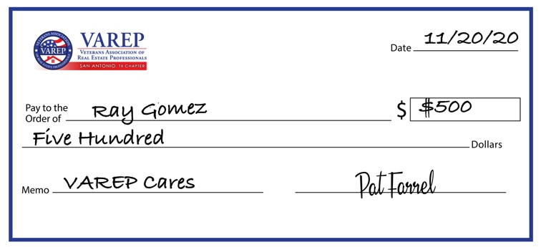

The local chapter check file is set up as a white board check that can be re-used for multiple events.

Step 1. Send email with PDF file to singsingsign@gmail.com
Step 2. Include the following:
Size 28x22 inches
Full Color
Print on foam board with dry erase laminate
Please include date when needed for delivery
Vendor will respond with price and will request shipping information and deadline details.

Any questions, please email jlopez@varep.net

